"Kyiv Vocational College of Communication"

Cyclic Commission of Computer Engineering

EXECUTION REPORT

**EXECUTION REPORT**

**LABORATORY WORK No. 1**

**Topic: "Getting to know the working environment of virtual machines and the features of the Linux operating system"**

It was performed by students of the RPZ group - 03B

Team 6: Sichkar Maxim,

Brytyuk Bohdan

Kyiv 2023

**The goal of the work:**

1. Familiarity with various types of hypervisors, virtualization when working with operating systems.

2. Familiarity with the main types of modern operating systems, a brief overview of their capabilities.

**Material provision of classes:**

1. IBM PC type computer.

2. OS family Windows (Windows 7).

3. Virtual machine - Virtual Box (Oracle).

4. GNU/Linux operating system - CentOS.

5. Cisco network academy site netacad.com and its online Linux courses

**Tasks for preliminary preparation.**

**The student prepared the material:**  Brytyuk Bohdan.

1. Read the short theoretical information for the laboratory work and make a small dictionary basic English terms on classification of virtual environments.

|  |  |
| --- | --- |
| **The term is in English** | **The term is in Ukrainian** |
| physical machine | фізична машина |
| software | програмне забезпечення |
| hypervisor technology | технологія гіпервізора |
| virtual devices | віртуальні пристрої |
| high bandwidth | висока пропускна здатність |
| virtualization | віртуалізація |
| user mode | режим користувача |

2. After reading the material from short theoretical information, answer the following questions:

**The student prepared the material:**  Brytyuk Bohdan

**2.1. Describe the concept of "hypervisor". What are their types?**

* A hypervisor is software that allows you to separate physical hardware from programs running in a computer's operating system. You can't "touch" it, it's all just unique software.
* When using hypervisor technology, it is possible to manage virtual devices from one host computer with one key. They act as guest operating systems. This kind of work makes the most efficient use of computing resources. The equipment receives high bandwidth. In short, the hypervisor is the real disruptive force that enables virtualization and VPS to function properly.
* Virtualization is a technology that allows you to create several virtual machines from one physical computer or server. The real hardware is called the host. It is characterized by the presence of powerful processors, disk and RAM, etc. Installation of special software (software) allows you to divide server resources into several virtual computers.
* It is accepted to divide hypervisors into two types - "Type 1" and "Type 2". Despite this, there is a third variety (hybrid), which combines the properties of both species.

**Hypervisor "Type 1"**

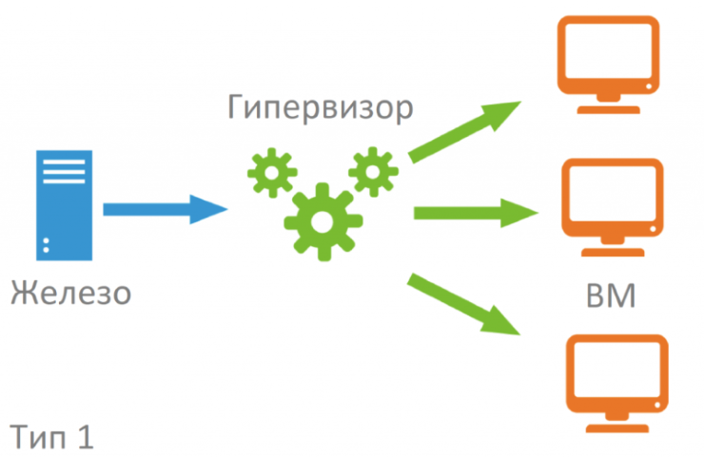

Guest operating systems that use the first type of hypervisor and function normally on it get the opportunity to run virtual machine services. This creates the illusion that with such an OS you can fully control all computer resources. By analogy, if a physical machine with supervisor mode access were used.

The first type (hardware hypervisor) has an important feature – its code takes up hundreds of times less space than modern OSes. It follows that the possibility of a critical error is reduced several times. The security of the system, which is responsible for virtualization, is achieved thanks to the complete transfer of the resources of the physical machine under the control of the virtual machine.

Hypervisors of the first type are VMware ESXi, Xen and others.

**Hypervisor "Type 2"**

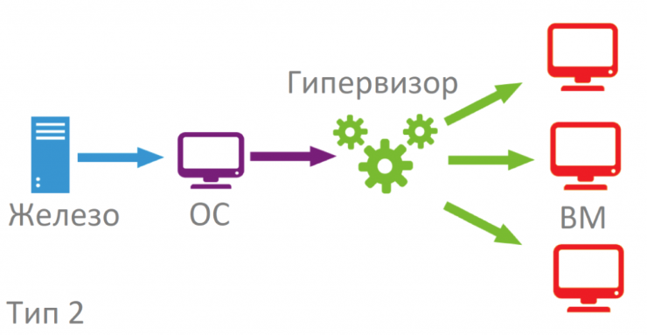

It has another name - host. Such technology is installed as a "second layer" on top of the installed operating system. In essence, this type is an application of the main operating system. Linux is often chosen for stable operation. All physical resources and emulation are managed from the host operating system. The second type of hypervisor has less authority. These include KVM, Oracle VM VirtualBox and others.

KVM

Hypervisor kvm stands for Kernel-based Virtual Machine. It was created in 2006. Almost immediately, it was used in the Linux 2.6.20 kernel. The kvm.ko module is responsible for virtualization. KVM is open source. It contains QEMU components for working in user mode and modules for Intel, AMD.

Oracle VM VirtualBox

The hypervisor can be used on any operating system. It was created in 2007 by specialists from Sun Microsystems. Like many similar products, it is distinguished by its open source code, which allows you to modify it an unlimited number of times. If VirtualBox is installed on a 32-bit OS, it is able to work with 64-bit guest systems.

**2.2. List the main components and capabilities of hypervisors according to your option (serial number according to the journal), table 1.**

Brytyuk Bohdan – 1 version

Sichkar Maxim – 23 version

**Progress:**

**The student prepared the material:**  Brytyuk Bohdan, Sichkar Maxim

***1. Watch introductory videos and demonstration materials from the following areas:***

*1.1. GNU/Linux. Basic information.*

*Access: https://www.youtube.com/watch?v=k4AKMLS2Ac8*

*1.2. Installing CentOS in VirtualBox.*

*Access: https://www.youtube.com/watch?v=W3XTYYoHe9A*

*1.3. Installing CentOS in text mode.*

*Access: https://www.youtube.com/watch?v=gOR-1o3K18Q*

*1.4. Installing the Gnome desktop environment on CentOS.*

*Access: https://www.youtube.com/watch?v=gcEiIH3KF4Y*

*1.5. Installing the KDE desktop environment on CentOS.*

*Access: https://www.youtube.com/watch?v=_ruIWLExaOY*

*1.6. The Shell (Linux)*

*Access: https://drive.google.com/open?id=0B0PV0_SM0LoDSVNPWUVRdUxaN2s*

*1.7. An overview of Linux graphical shells*

*Access:* [*https://www.youtube.com/watch?v=lEGplwLXZ78*](https://www.youtube.com/watch?v=lEGplwLXZ78)

**The student prepared the material:**  Brytyuk Bohdan, Sichkar Maxim

***2. After watching the video, answer the following questions.***

2.1. List the steps for deploying an operating system based on a VirtualBox virtual machine.

2.2. Are there any hardware limitations when installing 32-bit and 64-bit OS?

2.3. What are the main steps when installing CentOS in text mode?

2.4. How can you install Gnome and KDE graphical shells on CentOS, if it is already there

installed in text mode (specify necessary commands and packages)?

2.5. Give a brief description of the graphical interfaces used in different

Linux distributions according to their variant (serial number according to the magazine), table 2.

Brytyuk Bohdan – 1 version

Sichkar Maxim – 23 version

**The student prepared the material:**  Brytyuk Bohdan, Sichkar Maxim

**Answers to control questions:**

1. Compare type 1 and type 2 hypervisors, what is the difference between them and their scope?

2. Explain the concept of "GNU GPL", what is its basic concept?

3. What is open source software?

4. What is a distribution?

5. What tasks of system administration can be implemented on the basis of the Linux OS?

6. How are Android OS and Linux related?

7. Main capabilities and scope of use of Embedded Linux?

8. How can you change the type of Linux boot: in text mode (level 3) or graphical (level 5)? What is the difference between CLI and GUI modes?

***Conclusion:***